**Corona Warn App UIUX Analysis**

Menu bar flow

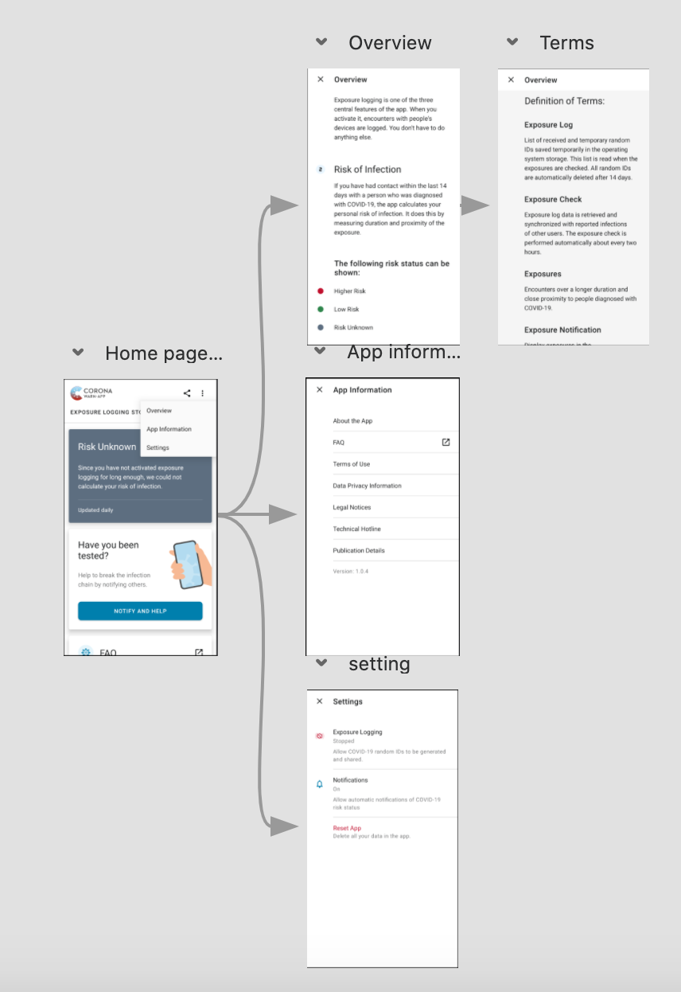

Risk Status and Report Positive